Roll No: 241901017
Name: H.Bharath krishnan
Department: CSE-Cyber Security

BUILDING ANONYMOUS FTP SCANNER USING FTPLIB MODULE

AIM:
To verify whether a specific FTP server allows anonymous login so you can audit and remediate insecure FTP configurations.
PROCEDURE:
1. Get written permission. Never test systems you don’t own or aren’t authorized to test. Put scope, time, and targets in writing.
2. Define scope. List the single host or hosts you are allowed to test. Limit testing windows to reduce impact.
3. Single-host check. Attempt one, non-intrusive anonymous login to each authorized host and record the result and server banner. Do not run broad network scans or automated high-rate checks unless explicitly allowed.
4. Log results. Save timestamped results (host, allowed/denied, FTP banner, any reachable directories) for reporting.
5. Report and remediate. If anonymous is allowed, inform the owner/operator, recommend disabling anonymous login or restricting it, and retest after remediation.
6. Follow up. Verify logs, ensure secure alternatives (SFTP/FTPS) are configured, and schedule periodic authorized audits.

PROGRAM:
import ftplib
def anonymousLogin(hostname):
try:
ftp = ftplib.FTP(hostname)
response = ftp.login('anonymous', 'anonymous')
print(response)
if "230 Anonymous access granted" in response:
print('\n[*] ' + str(hostname) +' FTP Anonymous Login Succeeded.')
print(ftp.getwelcome())
ftp.dir()
except Exception as e:
print(str(e))
print('\n[-] ' + str(hostname) +' FTP Anonymous Login Failed.')
hostname = 'ftp.be.debian.org'
anonymousLogin(hostname)

OUTPUT:
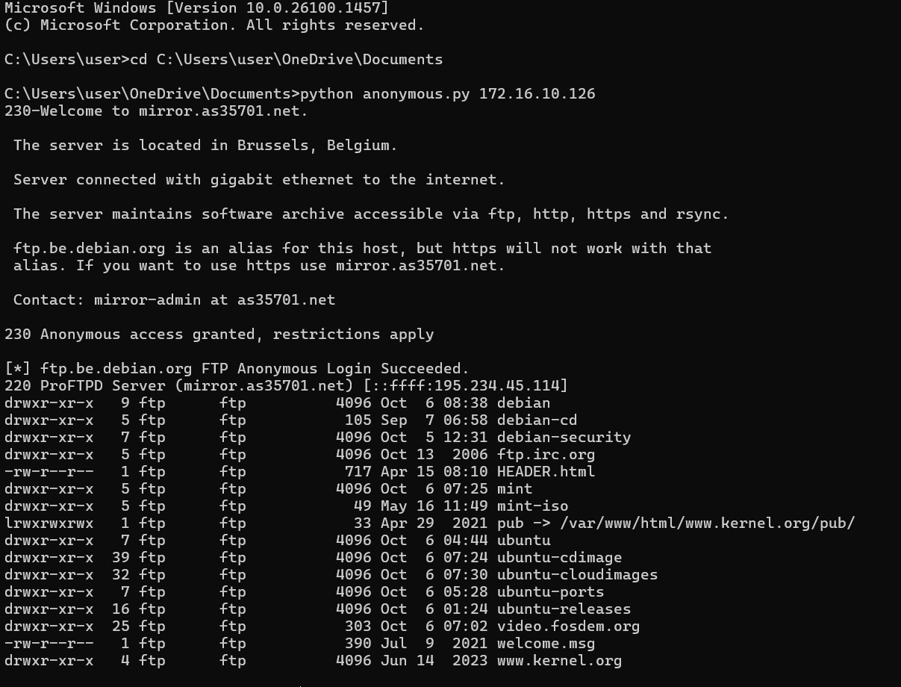

RESULT:
The expected results from running the anonymous FTP scanner. Therefore, anonymous FTP server using ftplib module is built and output is noted.

